Saraswathi
  - Product Design Architecture V1
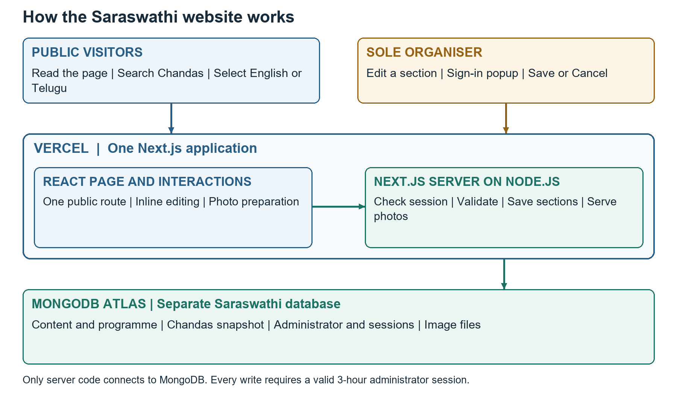
Figure 1 Browser interactions, the Next.js monolith on Vercel and the separate Saraswathi database.
This document explains how the Saraswathi Puja website will work, how the page and inline editing behave, and how authenticated updates and photos are stored and published. It is the engineering design baseline for the agreed V1.
Document detail | Value
Version and date | 1.0 | 15 October 2026
Celebration | 16 to 20 October 2026; main programme on 16 October
Owner and audience | Sole organiser; product design, engineering and testing
Status | Architecture baseline for review; implementation has not started

1 Architecture Overview
Build one TypeScript Next.js App Router application with React and Node.js Route Handlers, deployed to Vercel. A separate Saraswathi database on MongoDB Atlas Free stores content and images. No separate Express service is required. [S1 S2 S3]
The bilingual public page supports inline section editing. Edit requests sign-in when necessary; one Save publishes the whole section and closes its editor. Cancel discards the draft. Visitors see saved updates on the next load or refresh.

1.1 Trust boundaries
- Browser: public rendering, local drafts, search and image preparation; no database secrets.
- Server: authenticate every write, validate content and apply business rules.
- Database: persist content and images; keep account and session data private.

1.2 Scope of this document
This document defines behaviour, components, security, storage and operations. Detailed schemas, indexes and endpoint contracts follow in the database and API design stages.

2 Decisions and Product Boundaries
Decision | V1 design
Page and editing | One bilingual page; inline Edit, Save and Cancel per section
Administrator | One email and password; private hash; absolute three-hour session
Chandas | One whole-list editor; atomic Save; paid amounts or Pending
Photos | Original up to 5 MB; transmitted main image at most 3 MB; gallery cap 30
Persistence | Separate Saraswathi MongoDB database; binary image records
V1 boundaries | No public signup, extra administrators, recovery UI or separate dashboard

2.1 Latest agreed refinements
The later agreed refinements are inline editing, popup sign-in, three-hour sessions and no unnecessary compression of compatible images at or below 3 MB. Public visitors can open sign-in but cannot modify data.

2.2 Engineering baselines
Use the official MongoDB driver, CSS Modules, a shared React editor controller and server-side validation. Browser reads and writes use same-origin Route Handlers. State and storage stay within this monolith.

3 How the Page Works
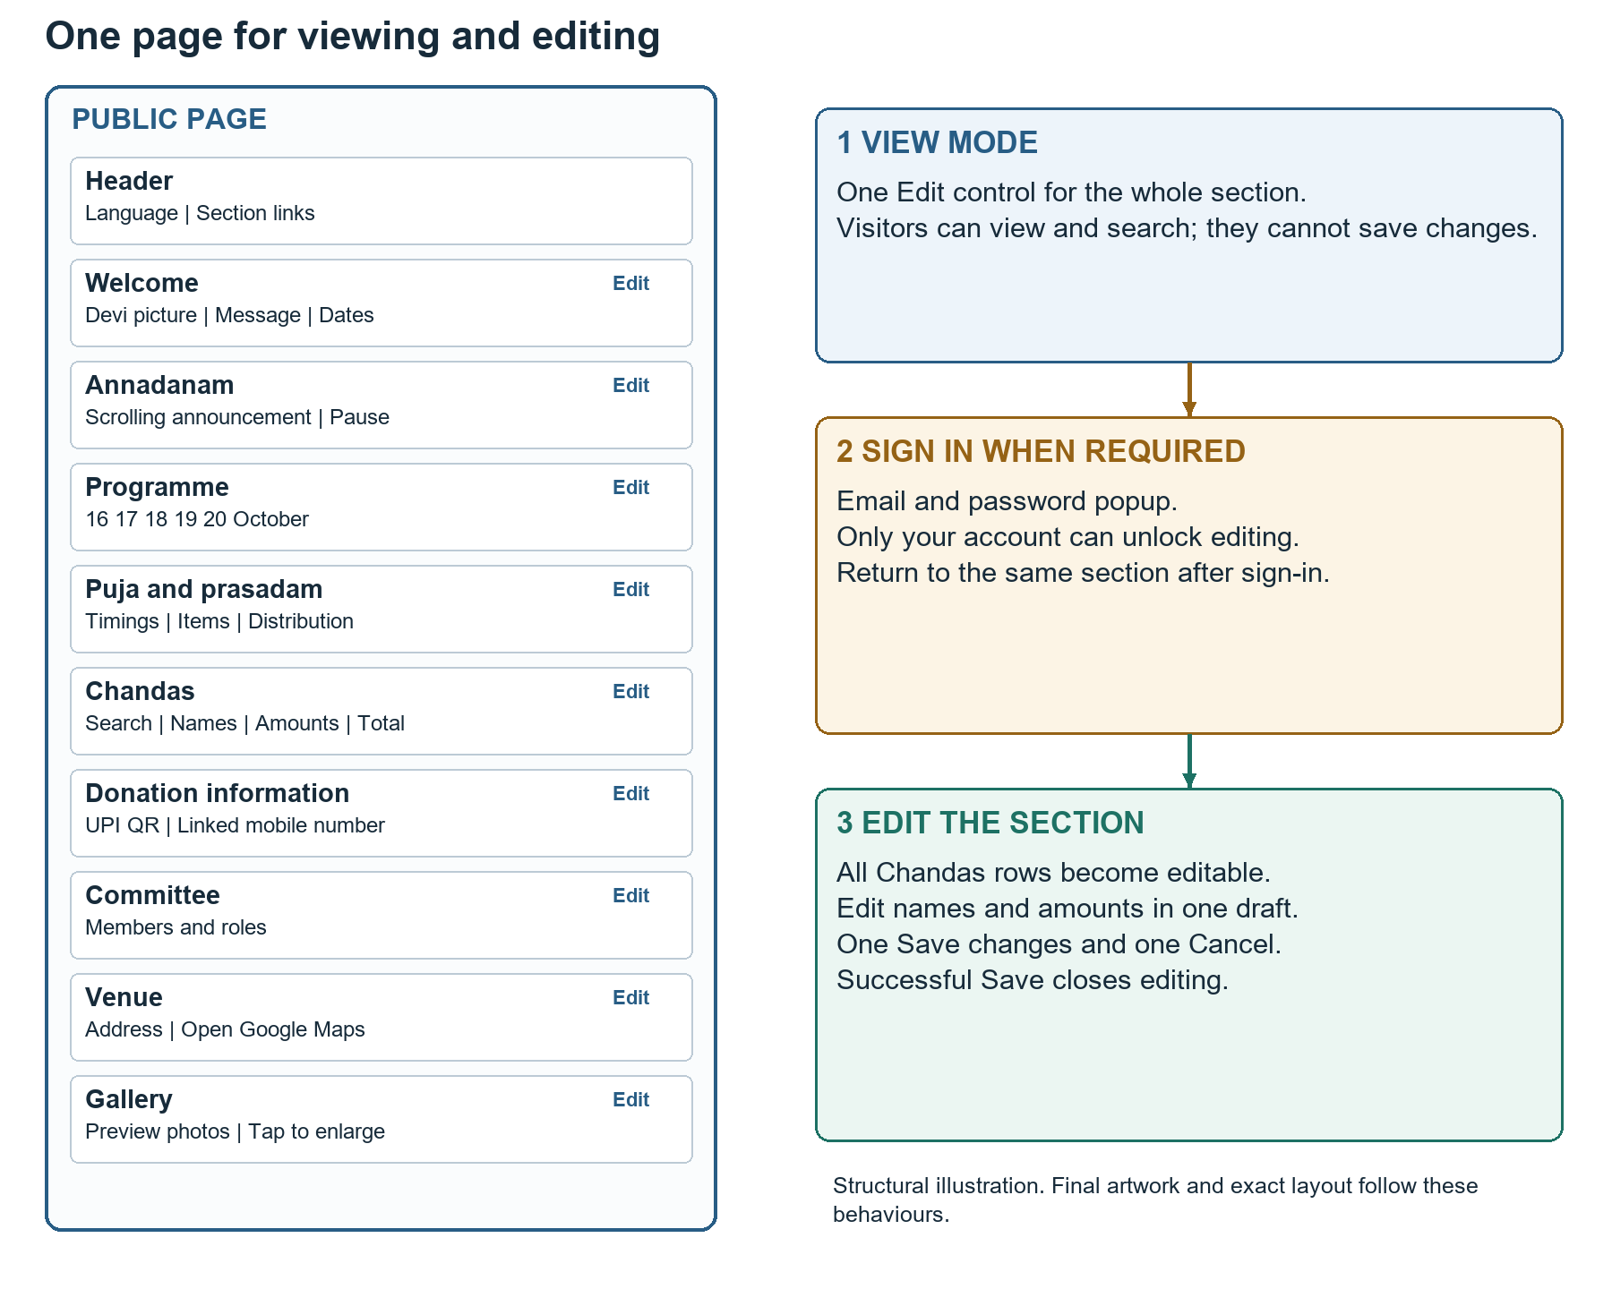
Figure 2 Structural page arrangement and the three main viewing, sign-in and editing experiences.
This is a behaviour diagram, not approved final artwork. A warm ivory background with restrained burgundy and marigold accents is the proposed visual direction. Preserve readable contrast, clear focus indicators and sufficient line height for Telugu text.

3.1 Section behaviour
- Header: celebration identity, English and Telugu switch, section links and signed-in status or sign-in entry.
- Welcome: approved Devi image, bilingual message, celebration dates and main programme.
- Annadanam: pending-date message initially; horizontal repetition with pause and reduced-motion support.
- Programme and prasadam: five date tabs or clearly labelled day blocks; daily events, puja timings, menus and distribution information.
- Chandas: search, total, update label and household rows; one section-level Edit entry.
- Donation information: verified QR, linked number and cash instructions.
- Committee, venue and gallery: approved people and roles, Google Maps link and combined image collection.

3.2 Responsive layout
On desktop, contribution rows can use a table and the hero can use two columns. On phones, rows may become compact cards and content stacks vertically. In edit mode each household exposes both name spellings and its amount input, without individual row Edit or Save buttons. Do not introduce page-wide horizontal scrolling at a 360 pixel viewport.

3.3 Editable sections
Use the same controls for welcome, announcement, programme, puja and prasadam, Chandas, donation information, committee, venue and gallery. Each section has one top-level Edit entry. Only the active editor shows Save changes and Cancel. Add and Remove actions for entries are inside the authenticated draft, with removal applied publicly only when the section is saved.

4 Initial Page Load and Rendering
1. The browser requests the public page over HTTPS.
2. The Next.js server reads public content through the shared data layer. Private administrator and session fields are excluded.
3. The server returns readable HTML and the data required for the current public view. [S1]
4. React activates language switching, day selection, search, photo enlargement and Edit controls.
5. The browser requests gallery preview images separately as they approach the viewport. Full-size images load only when needed.
6. An administrator session check affects available editing controls, not whether the public page is readable.

4.1 Server and client responsibilities
Server responsibility | Client responsibility
Read saved content and return public fields | Render and interact with the public sections
Verify identity and permissions on every write | Open sign-in and retain the intended section
Validate amounts and recompute canonical totals | Maintain unsaved names and amounts locally
Enforce image content and size limits | Convert or compress selected images before transfer
Persist section revisions and publish gallery references | Display progress, errors, conflicts and canonical success

Server Components can call the server data layer directly; they should not call their own HTTP endpoints. Browser operations use the same-origin handlers. [S2] Never send the whole image collection as Base64 inside the page content response.

5 Shared Inline Editing Design
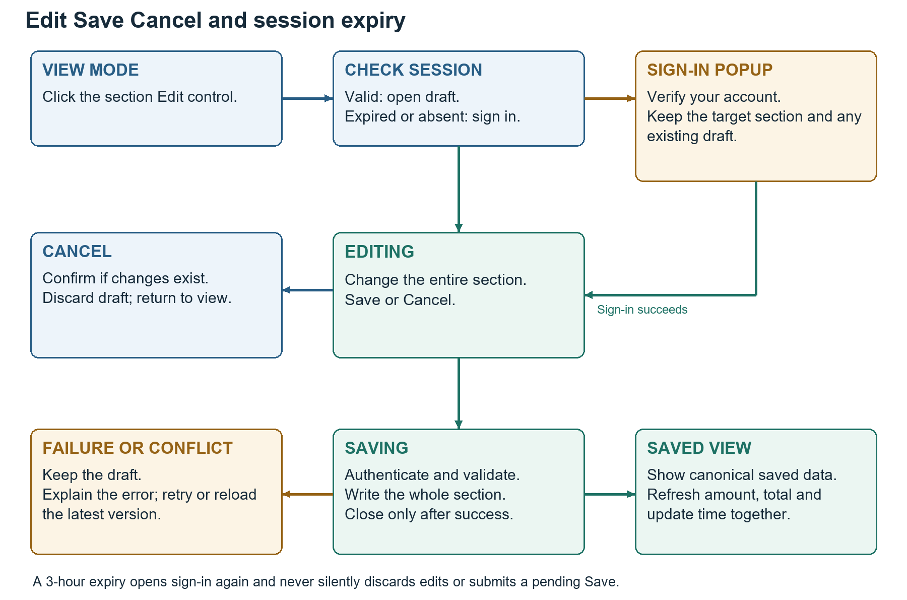
Figure 3 The common section editor state flow, including sign-in, Cancel, save failure and session expiry.

5.1 Editing state model
The shared editor tracks the active section, the original saved snapshot, a draft, its revision, dirty state and save operation identifier. Keep one active section editor at a time. Opening another section while edits exist asks whether to keep editing or discard them. A client boolean such as signedIn only controls presentation; the server still decides permission.
State | Visible behaviour
Viewing | Saved public content and one Edit entry
Sign-in required | Accessible email and password popup; underlying draft retained if any
Editing | Whole section draft with Save changes and Cancel
Saving | Progress indication; disable duplicate Save and Cancel until the outcome is known
Validation or save failure | Editor stays open; draft remains; errors explain what to fix
Conflict | Keep draft; explain that a newer version exists and require review
Saved | Replace view with canonical saved content and close editor

5.2 Cancel and navigation
Cancel closes an unchanged draft immediately. With changes, request confirmation, then discard only that draft. It must not call a write operation or remove published content. Warn on page navigation or reload when a draft is dirty. Drafts are retained in React memory while the sign-in modal opens; a full browser reload can discard them, so the warning is necessary.

5.3 Popup behaviour
Remember which Edit action opened the popup. A successful sign-in resumes that same section and scroll position. Cancelled initial sign-in leaves the public view unchanged. During session expiry, preserve the existing draft while signing in again, and require a new explicit Save. Trap keyboard focus inside the popup, label fields, allow dismissal and return focus to the triggering control.

6 Chandas Editing and Consistent Saving

6.1 Full list editor
Edit unlocks the complete list, including English and Telugu name fields and one amount field per household. Empty amount means Pending; a valid recorded amount means Paid. Status is derived from the amount, not maintained by a separate checkbox. Preserve stable household identities and supplied ordering, even if names are corrected or repeated.
Search in edit mode can filter visible rows but must not remove hidden households from the draft. Save applies to the complete draft, including edits made before filtering. Show a short changed-row count so the organiser understands how many rows will be saved. Approximately 130 households, including a list of 138, are within the intended scope; no fixed limit of 130 is imposed.

6.2 Atomic Chandas boundary
Represent the small Chandas list, its derived total, change timestamp and revision as one logical persisted aggregate. Implement its commit as one MongoDB document update that matches the expected revision. A single-document write provides the all-or-nothing boundary required by one Save for the entire list. This avoids assuming a multi-document bulk update is atomic. [S4]
1. Client validates visible and hidden draft rows and sends the whole intended snapshot with the original revision and a save identifier.
2. Server verifies session and request origin, then validates every row and allowed identifier.
3. Server converts rupees to integer paise and recomputes the total, ignoring Pending entries. It does not trust a client supplied total.
4. Match the expected current revision and write households, total, server update time, new revision and operation identifier together.
5. Return the canonical saved aggregate. Replace the public view and close the editor only after acknowledgement.

6.3 Validation and correction rules
- Require reviewed English and Telugu household names. Distinct households may share the same name; stable identifiers prevent accidental merging.
- Use blank as Pending, and reject invalid, negative or zero recorded amounts. Accept at most two decimal places and use integer paise internally.
- One household has one recorded contribution. A correction replaces its prior value; there are no instalments or repeat payment records.
- Confirm clearing a recorded amount or deleting a household with a recorded amount before including that removal in the draft.
- An unchanged Save is a no-op and does not advance the Chandas update timestamp.
- Timestamp changes only for committed Chandas changes; editing events or photos does not change it.

6.4 Conflict and uncertain results
A stale revision produces a conflict rather than overwriting a newer tab. Keep the draft and offer to reload and review the latest saved data. Do not silently merge contribution amounts. If the network fails after a possible commit, resolve the operation identifier or reread the saved aggregate before retrying. A retry must not add another contribution or advance a timestamp twice.

7 Administrator Account and Sessions

7.1 Account setup and password storage
The organiser chooses one email and password during private initial setup. Persist the email and a salted password hash in a private account record. Do not hardcode the readable password in React code, commit it to Git or return it through public handlers. The setup operation is separate from the public website and does not create a signup feature.
Use the Node.js asynchronous scrypt implementation as the password hashing baseline, with a unique random salt and an OWASP-aligned work factor. Store algorithm and cost parameters with the hash. Proposed baseline: N=2^17, r=8, p=1, with sufficient explicit memory allowance; benchmark on the selected Vercel runtime before release. Compare derived keys using a constant-time comparison. No password recovery UI is included. [S5 S6]

7.2 Session design
After valid credentials, generate a cryptographically random opaque session token. Store only a digest of that token with the administrator reference and an absolute expiry in MongoDB. Send the token in a server-set Secure, HttpOnly, SameSite=Strict cookie scoped to the site. Do not store credentials or session tokens in browser localStorage. [S3 S6]
- Expiry is exactly 10,800 seconds after sign-in. Activity does not renew it.
- Check session validity and absolute expiry on every protected read, upload and write, including the final publication commit.
- Database expiry cleanup is housekeeping, not access control; reject an expired record even if it has not yet been deleted.
- Sign out revokes the server session and clears the cookie.
- A browser countdown is a convenience; server time is authoritative.
- Store and compare timestamps in UTC, displaying event and update times in Asia/Kolkata.

7.3 Sign-in and write protection
Return a generic sign-in failure for an incorrect email or password. Add a small persisted failed-attempt throttle that works across serverless instances; a baseline is five failures per trusted source IP in fifteen minutes. Keep credentials and tokens out of logs. Enforce same-origin checks and a session-bound CSRF token on mutations. Never rely only on an Edit button being hidden.
Opening the sign-in popup is allowed for a visitor. Successful authentication against the sole administrator account is what unlocks editing. Public visitors retain reading access while signed out. A three-hour expiry preserves the local draft, requests sign-in again and never automatically submits an interrupted Save.

8 English Telugu and Search Design
Maintain explicit English and Telugu fields for public text and both household spellings. Store a language-neutral identity and one financial value per household. The language selector changes presentation without creating another record, changing totals or losing an active search.
- Use English initially; remember a selected language as a non-sensitive browser preference.
- Require both household spellings and the required bilingual content before saving. Show field-level messages for incomplete pairs.
- Normalise searchable text for Unicode and whitespace, and perform case-insensitive matching for English. Match partial text against both names.
- Search the loaded household list locally for this small data volume. Clearing search restores the list; a failed initial read is not a no-match result.
- Keep English and Telugu editing labels side by side or stacked on phones. Treat names as reviewed spellings, not automatically translated prose.
- Load fonts with Telugu glyph support and test long names, line breaks and screen-reader labels.

9 Programme Devotional Content and Location

9.1 Five day presentation
Use date tabs or clear daily blocks for 16 to 20 October 2026. Identify the main programme on 16 October. Each date remains visible even without detailed events. Show confirmed timings in India time and honest bilingual pending text for information not yet supplied.
The Programme editor opens all five days within one section draft and has one Save and Cancel pair. Within it, the administrator may add or remove event entries. Do not delete the five fixed day slots. Puja and prasadam use the same pattern, with day-associated timing, menu and distribution information. Shared presentation must not show contradictory copies of the same saved details.

9.2 Annadanam
Begin with the approved bilingual pending-date message. Its horizontal movement is slow and can be paused; reduced-motion visitors receive static text. One section editor replaces it with confirmed date, time and venue when available. Annadanam is not assumed to fall within the five programme days.

9.3 Committee and venue
Publish approved bilingual member names and roles; photos and a single approved public contact are optional content. Committee membership grants no permissions. Store a supplied venue name, address and Google Maps location link. Validate a safe HTTPS map link and open it with an external-link indication. An embedded map API is not required.

9.4 Donation information
Show the verified UPI QR image, linked number and cash contribution instructions. Enlarging or scanning a QR never marks a contribution paid. The organiser verifies receipts separately, then records the household amount. QR replacement follows the same section-level Edit, Save and Cancel publication rules.

10 Photo Formats and Size Policy
Rule | Architectural value
Original selection limit | 5,000,000 bytes per selected image
Main transmitted image limit | 3,000,000 bytes after any conversion or compression
Input formats | JPEG/JPG, PNG, WebP, HEIC and HEIF
Compatible input at most 3 MB | Retain main image without unnecessary recompression
Input above 3 MB up to 5 MB | Compress in browser before sending to Vercel
HEIC or HEIF input | Convert to a broadly displayable format, then check final size
Gallery cap | 30 published items, independent of the initial household count
Preview images | Separate small thumbnail; target at most 200 KB
Original retention | Only the published optimised version is stored; original stays on the device

MB is defined here as 1,000,000 bytes for consistent browser and server validation. Conversion can increase size, so even a small HEIC must be checked again after conversion. Every transmitted main image must remain within 3 MB. The thumbnail is a separate delivery variant, not a second gallery item.

10.1 Conversion and compression
Use browser image decoding for JPEG, PNG and WebP. Dynamically load a tested HEIC/HEIF converter only when required; heic-to is the candidate browser decoder and supports a CSP-oriented build. Pin a tested release during implementation. Run expensive conversion in a worker where supported and keep the interface responsive. [S7]
For a compatible image already at or below 3 MB, avoid changing the main file solely to reach an arbitrary target. For larger or converted images, progressively adjust quality and dimensions until the output fits. Show a preview and resulting size. If conversion or compression fails, explain the issue before uploading; never silently upload an unsupported original.
Correct image orientation and retain an appropriate output format for transparency. Generate small previews separately. Validate real file signatures and successful decoding on the server, with bounded processing resources. RAW files, videos, animation and every possible specialist format are not promised by the common-phone-photo support requirement.

11 Photo Upload Storage and Publication
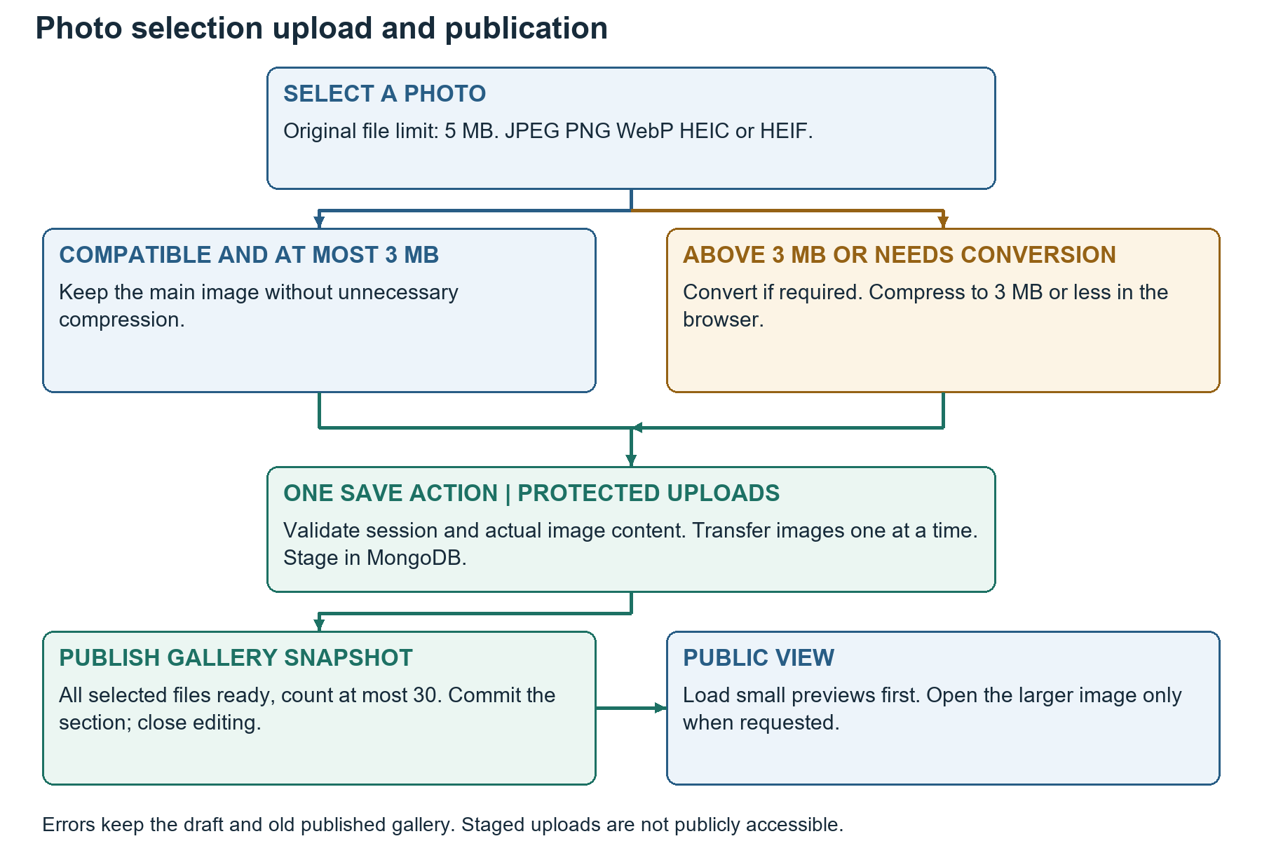
Figure 4 Originals are checked and prepared in the browser; protected uploads are staged before one gallery publication Save.

11.1 One gallery Save with multiple transfers
1. Edit opens a draft of the full gallery. Selecting photos creates private local previews, not published images.
2. Check the 5 MB original limit and available gallery slots. Convert or compress each selected image as required.
3. On Save, validate the administrator session and upload prepared images sequentially, one file per request. One Save click can coordinate multiple requests.
4. Store each new image as unpublished staged media belonging to the organiser save batch. Return private staged identifiers, not public gallery access.
5. Once every intended addition is ready, commit the revised gallery reference list with its expected revision and enforce at most 30 published items.
6. After publication succeeds, close editing and render the canonical saved gallery. Then remove unreferenced replaced or deleted media safely.

11.2 Why uploads do not use Vercel disk
Vercel runs the application code, not the durable photo store. Upload bytes are written into MongoDB binary records, with main images served individually. Do not write new gallery files into the repository public folder, the deployment bundle or temporary filesystem expecting them to persist. A 3 MB image leaves headroom under the current 4.5 MB Vercel Function payload limit. Use binary multipart transfer rather than Base64 JSON. [S8 S9]

11.3 Failure and cleanup
A failed transfer keeps the draft and prior public gallery unchanged. Retry staged transfers using a save-batch identifier without creating duplicate published photos. A session expiry requests sign-in and rechecks permission before continuing. Staged images are not readable through public image routes. On uncertain final results, resolve the batch before retrying or deleting its files.
Publish the gallery reference list in one atomic update; staged files can be written beforehand without becoming public. Removal first changes the published references, then cleans up files. A failed cleanup may leave an unreferenced private file temporarily but must not break a published image. Reclaim abandoned staging batches through a documented maintenance procedure; check capacity and clean them before they consume the free quota.

12 MongoDB Boundaries and Data Access

12.1 Separate database and account scope
Create a Saraswathi database, for example saraswathi_puja, on the chosen existing Atlas Free cluster. Use a dedicated database user restricted to that database. Do not reuse a broadly privileged application account or read and write Make My Marriage collections. Logical separation does not create separate cluster storage, throughput or connection allowances.

12.2 Logical persistence groups
Logical group | Responsibility
Public section aggregates | Welcome, announcement, programme, puja and prasadam, committee, venue and payment information
Chandas aggregate | Stable household identities, bilingual names, amounts, total, revision and update time
Gallery aggregate | Canonical published media references, count and revision
Media records | Binary main image and preview variants plus private staging or published reference state
Private identity | One administrator password hash, sessions and sign-in throttling records

These are persistence boundaries, not final collection schemas. Small section aggregates support atomic section-level saving and revision checks. Keep image bytes outside ordinary section records. The database design will define fields, indexes, size guards, stable identifiers and lifecycle details.

12.3 Connection use and binary images
Use a reused MongoClient per warm server runtime with a small bounded connection pool; do not create a new pool on every request or close the shared client after each operation. An initial pool maximum of five per runtime is a tunable baseline, to be verified under Vercel concurrency and the shared cluster workload. [S10]
Store each small image as BSON binary rather than a Base64 string. A main image of at most 3 MB plus its preview fits comfortably below MongoDB document size limits; large-file GridFS is not required for this V1 approach. Serve only one requested variant per response. [S9 S11]

13 Freshness Caching and Image Delivery

13.1 Public content reads
Use explicitly fresh public content and Chandas reads for V1. Do not prerender the full mutable page once at build time or cache it indefinitely. Account and session responses are private and not shared-cacheable. A public refresh must return saved data without requiring a new deployment.
After saving, use the server response to replace the active section snapshot and invalidate any relevant client snapshot. No optimistic public contribution totals are displayed before commit. Existing visitor tabs update on their next read or refresh; WebSockets and automatic live polling are excluded. Next.js caching behaviour must be configured and tested explicitly for the selected framework release. [S2]

13.2 Images and bandwidth
Use stable versioned image identifiers. Load small previews lazily, opening the main file on demand. Public image responses can use cache validators and a bounded public cache lifetime so repeated viewing does not repeatedly read full image bytes from Atlas. Never apply public caching to staged uploads or authenticated edit data.
When an image is replaced, publish a new immutable image identity rather than changing bytes under a long-cached URL. Deleting an image removes it from the current gallery, although already downloaded public copies or browser caches cannot be revoked. Avoid serving all 30 full-size photos on initial load.

14 Validation and Security Controls
- Check administrator identity, session expiry and request origin for every write, and reject public attempts before changing data.
- Use a session-bound CSRF token for mutations, strict input allowlists and server validation even when browser validation passes.
- Treat public prose as plain text rendered safely; do not accept arbitrary HTML, script snippets or executable map URLs.
- Return only approved public fields. Do not leak password hashes, session digests, connection strings, throttling internals or private upload batches.
- Validate actual image type, byte size and decode success. Public file responses use the correct content type and prevent content sniffing.
- A public image identifier must be referenced by currently published content; knowing a staged identifier is not sufficient to read it.
- Use a scoped database account, HTTPS and server-only environment variables. Never prefix secrets with NEXT_PUBLIC_.
- Log operation identifiers and concise errors, not readable passwords, tokens, full contribution drafts or database credentials.
No public signup, password recovery screen, committee account creation or role invitation is added. Initial account provisioning is a controlled setup operation. Security controls protect the already agreed sole-administrator model; they are not additional visitor features.

15 Vercel Deployment and Configuration

15.1 Deployment unit
One repository produces one Next.js deployment with React components, same-origin Route Handlers and server-only modules. Use a supported Node.js runtime compatible with the pinned Next.js and MongoDB driver releases. Lock dependency versions and verify production builds rather than relying on an unpinned latest version.

15.2 Configuration boundaries
Configuration | Handling
MongoDB connection and database name | Server-only Vercel environment settings; scoped to Saraswathi
Public application origin | Used for canonical links and same-origin validation
Session cookie and expiry | Secure host-scoped cookie; fixed 10,800 second server expiry
Image and gallery limits | Shared validation constants; server is authoritative
Preview and production | Separate credentials and non-production database for write testing
Initial account credentials | Private one-time setup input; never committed or included in the browser bundle

Do not allow preview deployments or automated tests to write the production Saraswathi data. The next database design should define an isolated non-production database or equivalent safe fixture boundary. Production deployment rollback changes code; it does not automatically restore MongoDB records or images.

15.3 Network and release preparation
Configure Atlas network access for the selected Vercel connectivity approach using TLS and the scoped database account. Use the narrowest practical access configuration for the plan. Keep secrets in deployment settings and verify a production read, sign-in, whole-section Save and image upload before sharing the site.

16 Atlas Capacity Backup and Operations

16.1 Shared free-tier capacity
Atlas Free provides about 512 MB for data and indexes at the cluster level. A separate Saraswathi database on the existing cluster shares that allowance with Make My Marriage. Thirty main images at 3 MB each consume up to 90 MB before previews, other assets, staging records and indexes. Available headroom must be measured rather than assumed. [S12]
Atlas Free also has transfer and operation limits. At the current published limit of 10 GB outbound per rolling seven days, repeatedly retrieving a full 90 MB gallery can consume significant capacity. Lazy previews and image caching are operational requirements, not optional decoration. Check both projects before and during the celebration. [S12]

16.2 Backup procedure
Atlas managed backups are not available on Free. Take a private manual database backup using supported tooling before launch and after each completed daily collection update or significant photo batch. Include binary media and private session collections in the protected backup; do not publish it in Git or on the website. [S13]
1. Complete or pause administrator writes so the manual backup is consistent for this small single-owner site.
2. Back up only the Saraswathi database; do not capture or restore the whole shared cluster unnecessarily.
3. Keep the protected archive in an organiser controlled location outside public deployment assets.
4. Test a restore into an isolated non-production database and verify names, totals and image references.
5. During a real restore, pause writes, verify the selected database target, restore, invalidate restored login sessions and recheck totals and photos before reopening editing.

16.3 Continuing access
Do not promise permanent availability independent of hosting and Atlas account status. Free clusters can pause after prolonged inactivity. The website retains its information after event dates, but the organiser must keep hosting and the database available and keep a backup. No automatic deletion after 20 October is implemented. [S12]

17 Failure Handling and Recovery
Failure | Required outcome
Public content read fails | Show failure and retry; do not display an invented empty list or zero total
Sign-in fails | Generic message; preserve target section; apply persisted throttle
Three-hour session expires | Open sign-in on protected action and preserve the in-memory draft
Invalid Chandas row | Show row and field errors; commit none of the list
Revision conflict | Keep draft; require review of latest data; do not silently overwrite
Network result uncertain | Resolve operation or batch identifier before repeating a write
Photo conversion fails | Explain format or processing failure before upload
Upload or gallery Save fails | Keep the draft and prior published gallery; no broken published file
Media cleanup fails | Preserve valid published files; retry private orphan cleanup safely
Capacity limit reached | Stop new uploads with a clear message; preserve recorded data

Make the difference between a draft, staged bytes and published content explicit. A failed operation is never represented as a successful Save. Errors should guide the organiser without showing internal diagnostics to public visitors.

18 Component and Project Organisation
Logical area | Responsibility
App Router page and layout | One public route, metadata, initial rendering and application shell
Public section components | Welcome, programme, prasadam, Chandas, donation, committee, venue and gallery
Shared editing controller | Edit entry, active section, draft, dirty state, Save, Cancel and popup continuation
Authentication module | Private account verification, sessions, sign-in, sign-out and CSRF checks
Domain services | Chandas arithmetic, revisions, section validation, publication and image policy
Data access layer | Server-only MongoDB reads and writes using scoped connections
Media pipeline | Browser preparation, protected staging, publication references and preview delivery
Presentation resources | CSS Modules, bilingual labels, Telugu-capable fonts and accessible controls

Keep business rules in shared server services, not duplicated inside React components and handlers. Public projection functions are separate from private account reads. The route map and request shapes will be specified in API design; detailed folders can follow these logical boundaries during implementation.

19 Verification and Release Gates
Check | Pass condition
Public single page | Every section, English and Telugu, search and Maps are usable
Whole section editing | One Edit, Save and Cancel per section; no household-level Save buttons
Authentication gateway | Signed-out Edit opens a popup and returns to the same section after valid login
Session duration | At three hours, protected operations fail until sign-in; activity does not extend expiry
Atomic Chandas Save | One invalid row or failed commit leaves the whole public list unchanged
Totals and status | Blank is Pending, saved positive value is Paid; sum and timestamp agree
Conflict and retry | A stale tab cannot overwrite a newer revision; duplicate retry does not duplicate results
Compatible small image | A 2 MB or 3 MB compatible image is not unnecessarily recompressed
Larger or HEIC image | A selected file at most 5 MB is converted or compressed to at most 3 MB before transfer
Gallery Save | One Save coordinates sequential uploads and publishes only the completed list
Gallery capacity | Thirty photos allowed; a 31st is rejected without harming published images
Publication access | Unpublished staged files and private records cannot be read publicly
Persistence and isolation | Restart and redeploy preserve photos; no writes to Make My Marriage
Backup restore | An isolated restore reproduces Chandas totals and readable photos
Mobile and accessibility | Real iPhone and Android files, 360 pixel layout, keyboard and Telugu text pass

Release only after the single administrator journey and the public read journey pass against the production deployment. Use non-production fixtures for testing, remove test content, verify the QR and Maps destination, and confirm a current private backup.

20 Handoff to Database and API Design

20.1 Database design must specify
- The Chandas aggregate structure, stable household identifiers, integer paise rules, revision check and operation result resolution.
- Public section aggregates, gallery publication references and private staged media lifecycle.
- Administrator password hash parameters, opaque session digests, expiry indexes and failed-attempt counters.
- Binary image variants, metadata, public reference checks, cleanup rules and per-record size limits.
- Indexes, database permissions, non-production isolation, backup and restoration procedures.

20.2 API design must specify
- Public section and image read contracts containing only allowlisted fields.
- Sign-in, session status, sign-out and protected section mutation contracts.
- Whole Chandas snapshot Save with expected revision and operation identifier.
- Staged sequential image transfer and final gallery publication with batch resolution.
- Validation, authentication failure, expiry, conflict, request-size, retry and uncertain-commit responses.

20.3 PRD alignment
Keep the latest approved behaviour consistent across the PRD and later design documents: inline editing for every section, one Chandas Save, three-hour sessions, no recovery feature and the 5 MB original versus 3 MB uploaded-image rule. This document does not change the existing PRD file or begin implementation. Content inputs such as final committee names, programme times and household spellings remain organiser supplied.

21 Technical References
Official documentation reviewed on 15 October 2026. These support platform facts and technical constraints; product-specific choices in this document are the Saraswathi engineering design baseline. Recheck hosting limits and dependency compatibility before deployment.
S1 Next.js Server and Client Components
S2 Next.js Backend for Frontend and server-side data access
S3 Next.js Authentication and session guidance
S4 MongoDB atomicity and expected-value update conditions
S5 OWASP password storage guidance
S6 Node.js cryptography API
S7 heic-to browser HEIC and HEIF conversion project
S8 Vercel Function payload and runtime limitations
S9 MongoDB BSON binary data support
S10 MongoDB driver connection pooling
S11 MongoDB image storage and small-file alternatives to GridFS
S12 Atlas Free cluster limits and shared storage
S13 Atlas backup and restore guidance

